DESIGNING RESTFUL WEB APIs

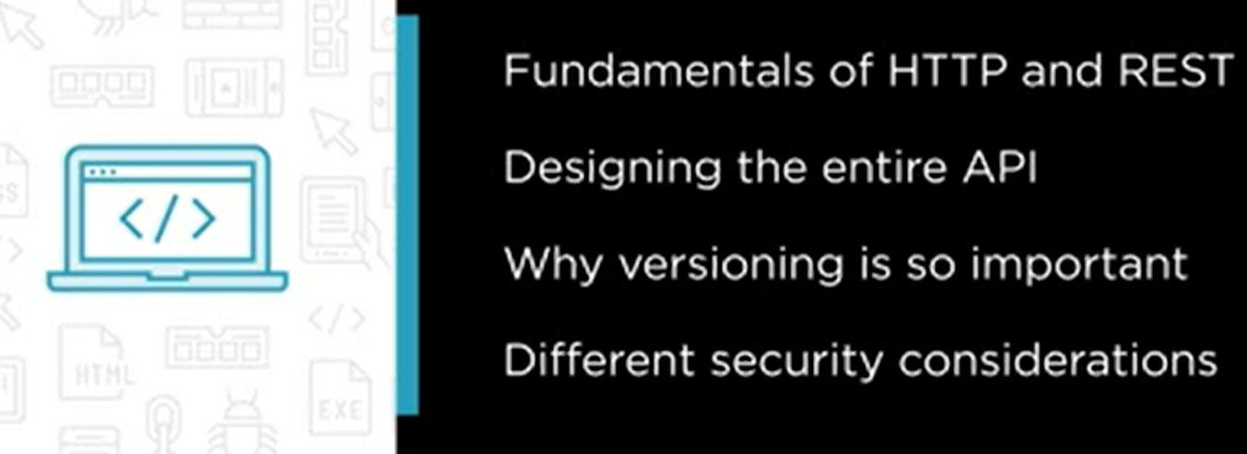

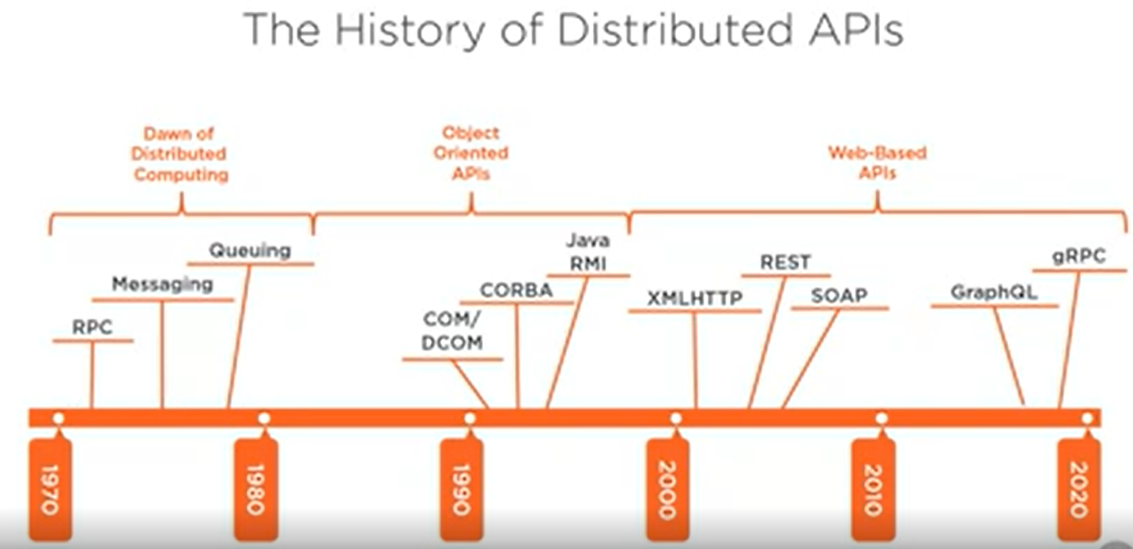

**API** – application programming interface is a software technique through which 2 or more applications/computers communicate with each other in a distributed system. With the help of API services are exposed for external world to use them.

**What is REST API?**

Representation state transfer is a software architectural design through which data (called as state) is transferred between client and server over internet using URI.

FIRST QUESTION IS WHY WE NEED A WEB API?

1. If we have a desktop application we don’t need a API.
2. We need a web API when some client is trying to get some information from our services which is deployed on some other server.

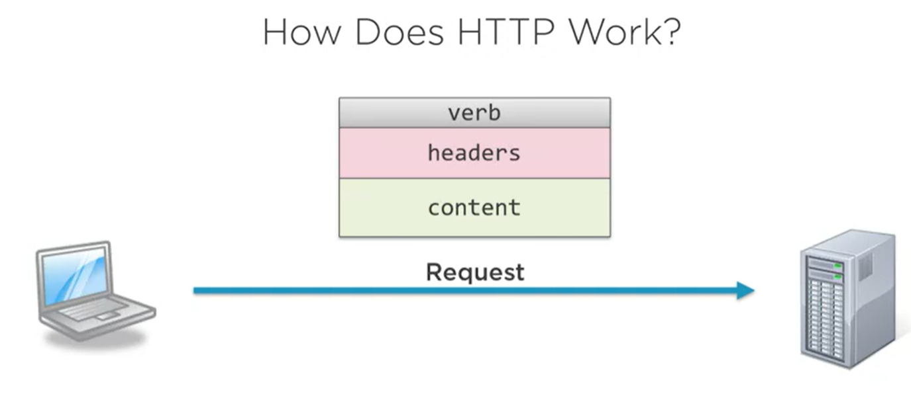

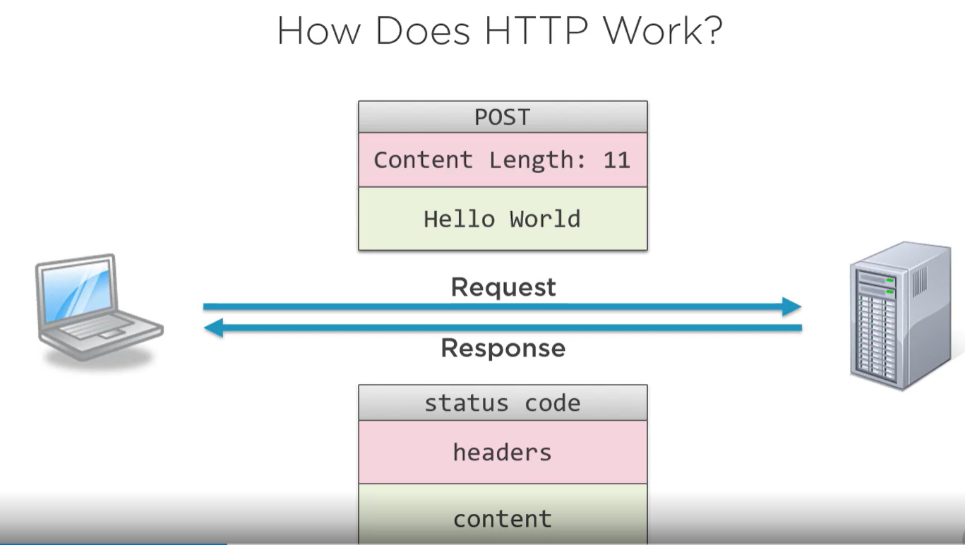

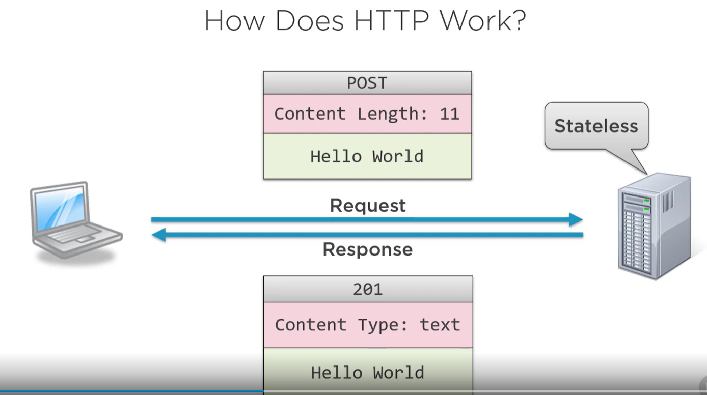

Each network request is short lived. Synchronized. STATELESS REQUEST. Once server sends response it forgets about the request. To save memory and serve multiple request at same time.

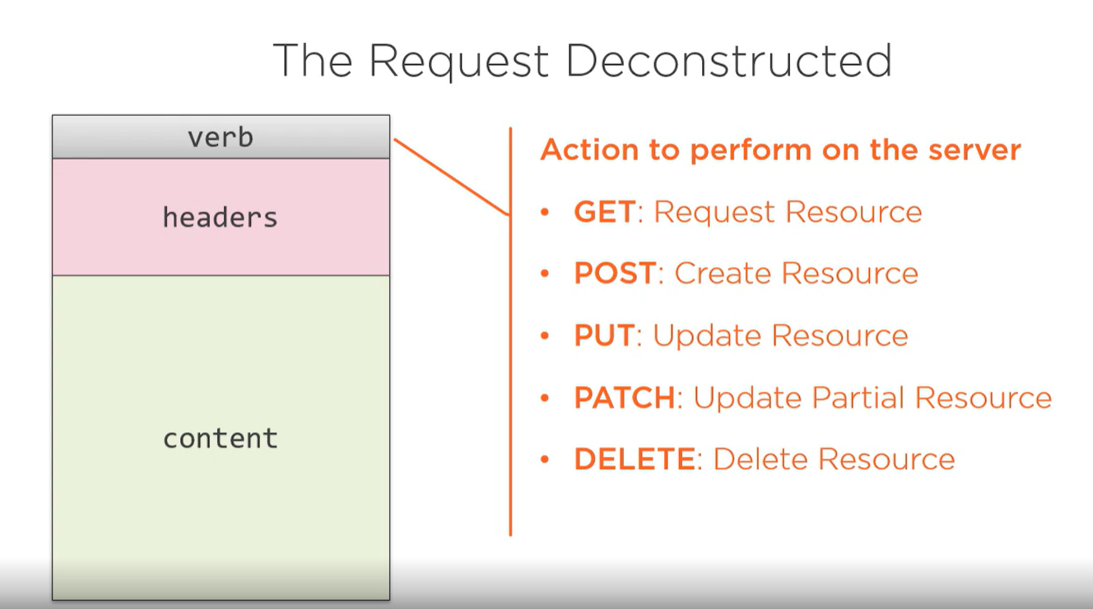

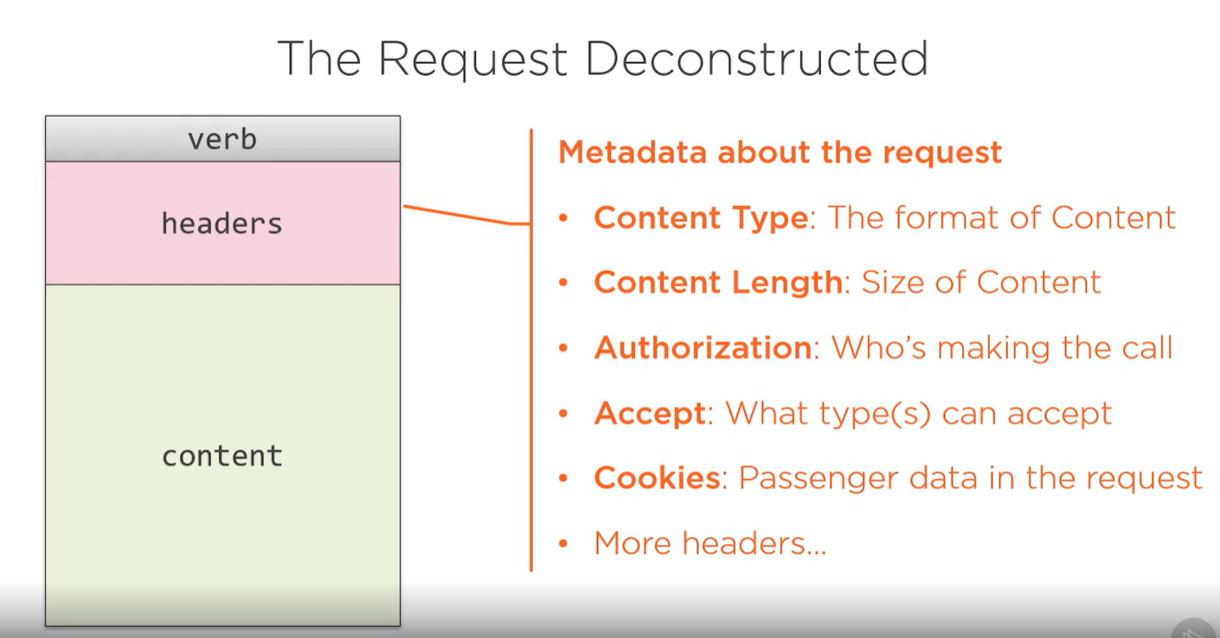

These are name-value pair

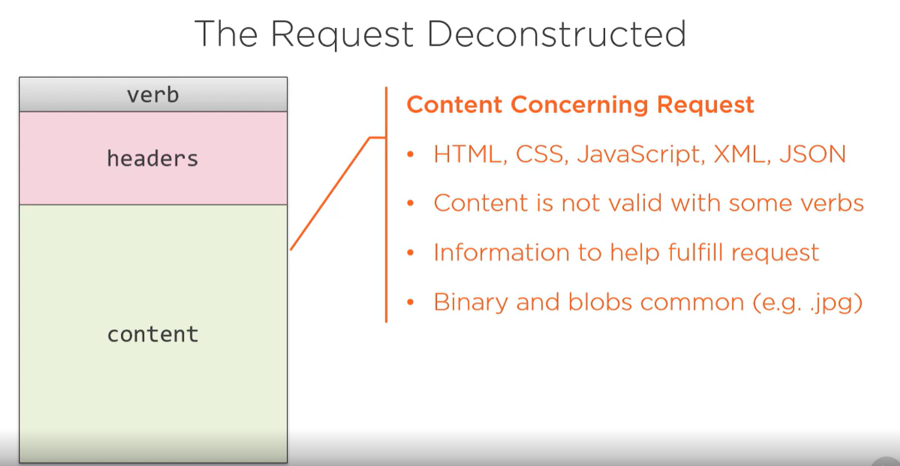

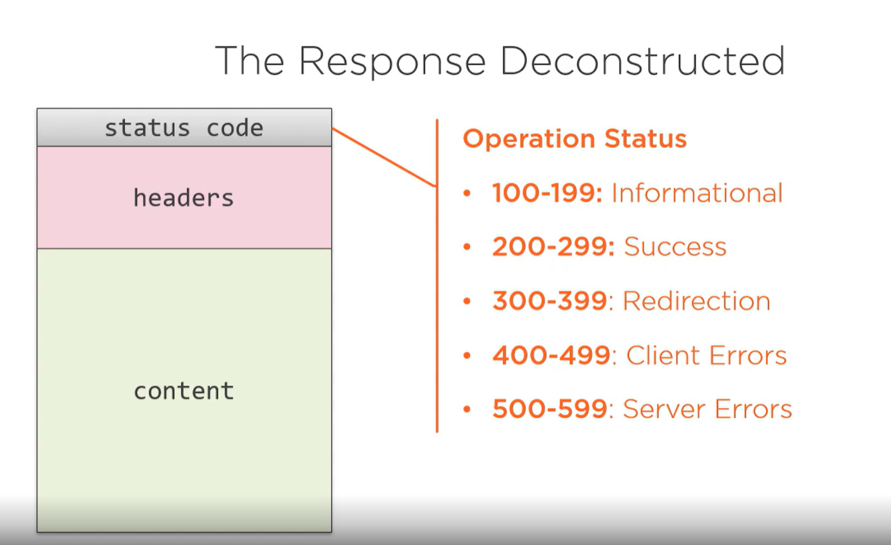

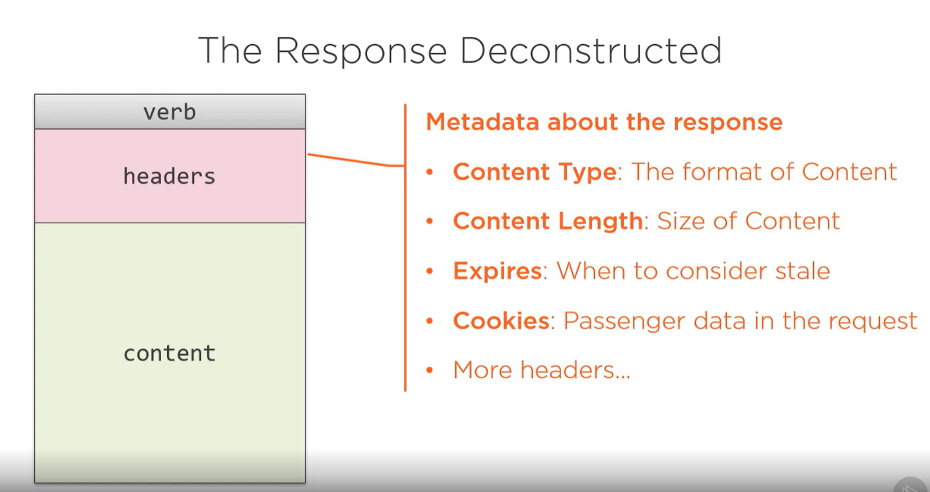

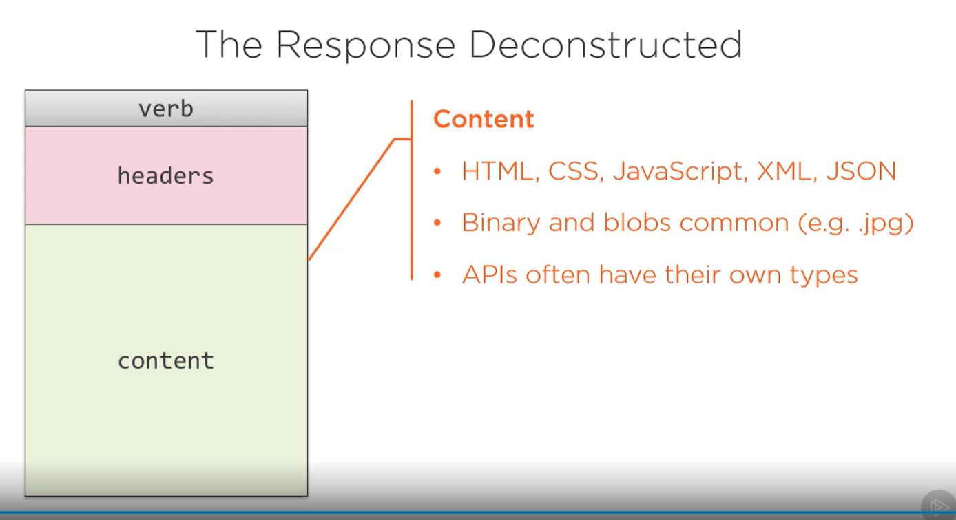

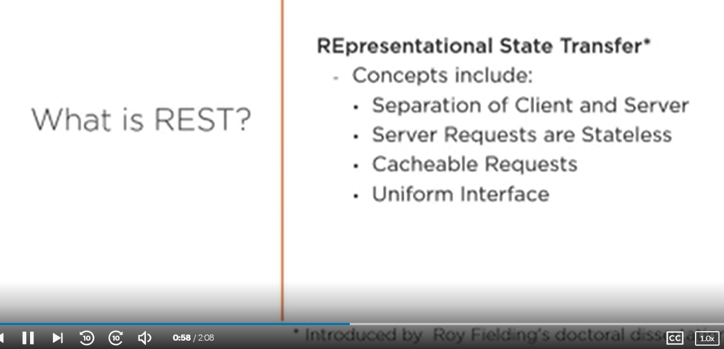

Transfer of state(data) in a representation way. Means we have proper body in which we post or save request and we get response also in a proper way.

Roy Fielding create REST.

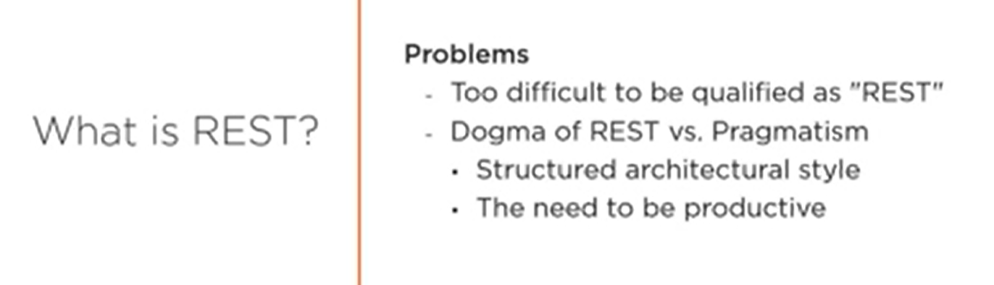

DESIGNING AN API

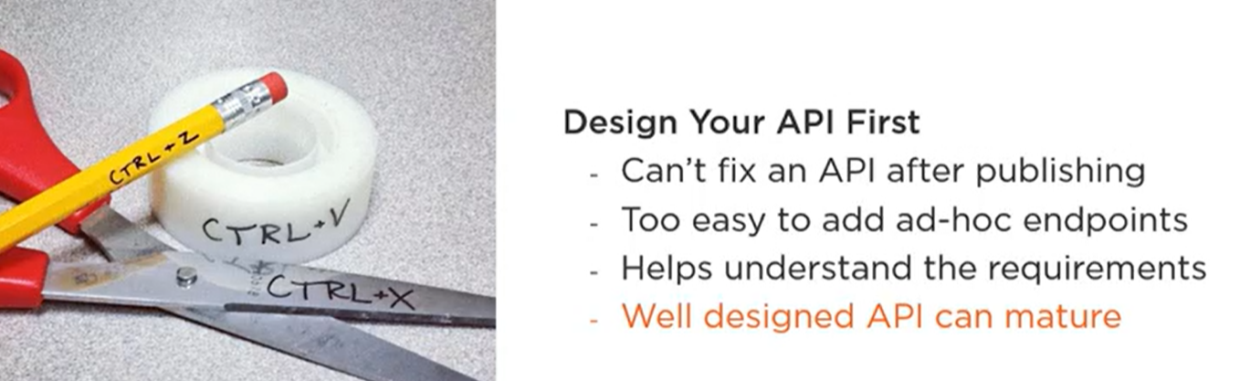

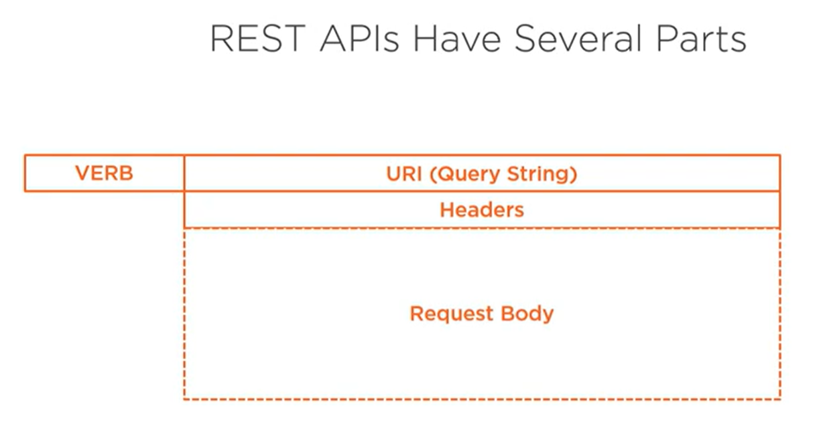

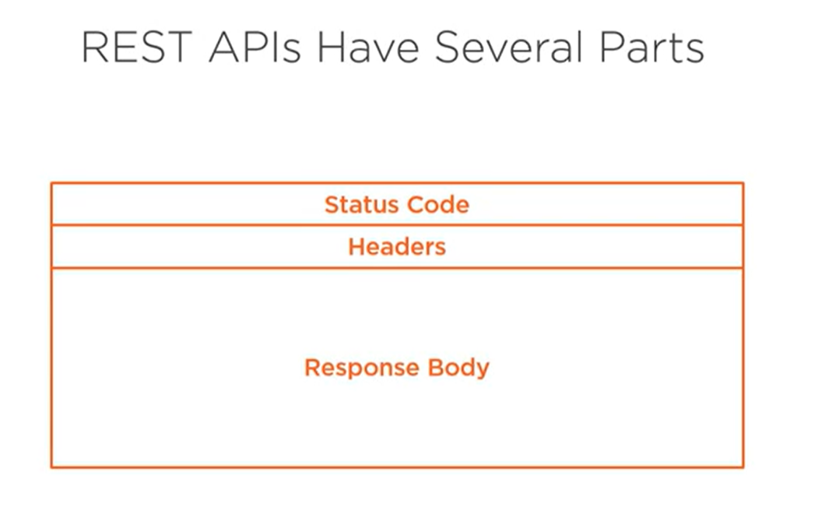

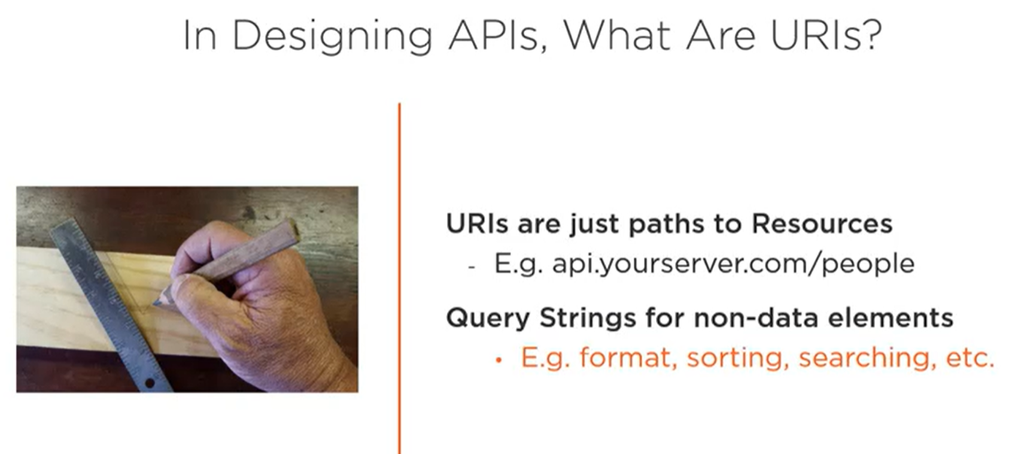

Resources are complex objects or single objects that we are exposing through the API.

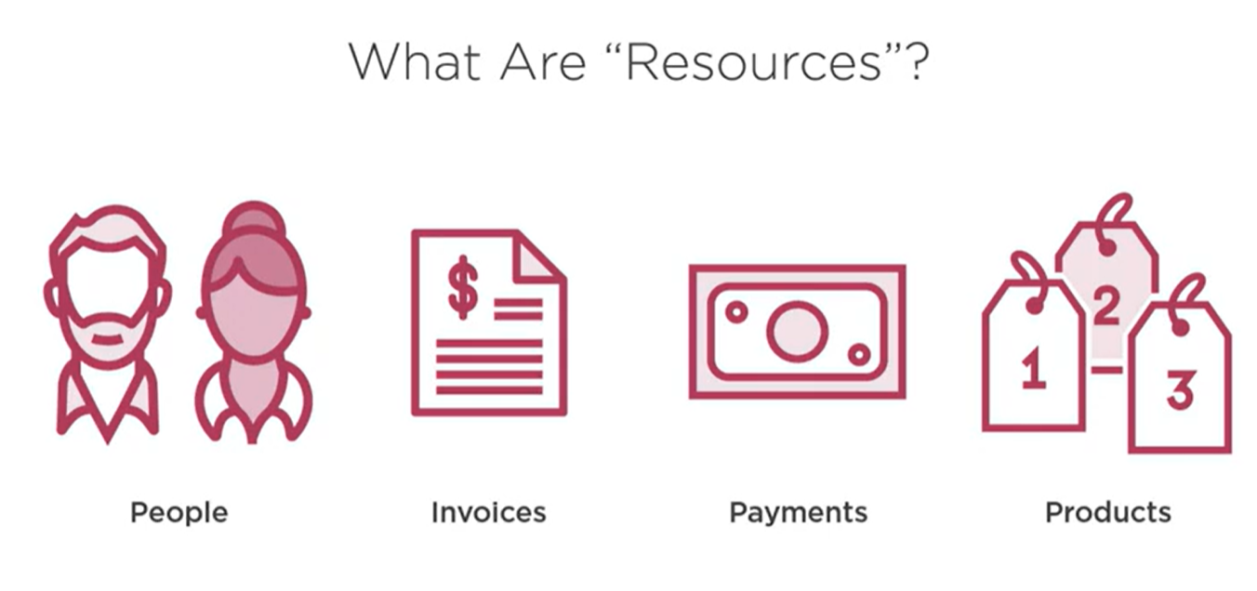

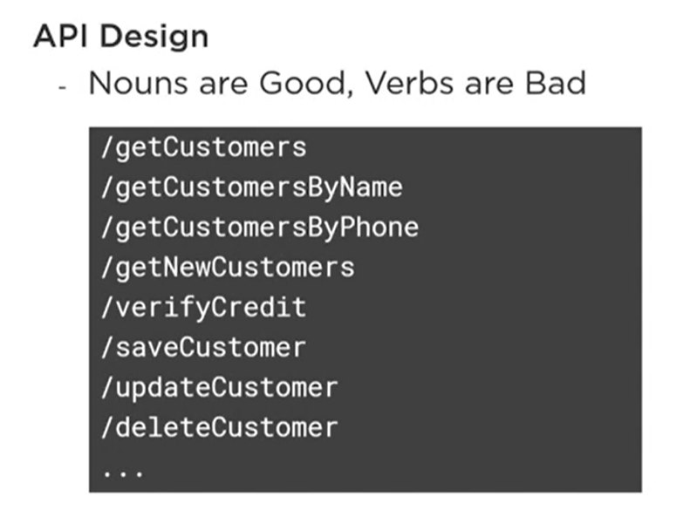

In REST we use nouns instead for verbs.

